Navigate Scavenger Hunt
  - SDSS Voyages – Gravitational Lensing Student Worksheet

Learning Intentions: We are learning how to use the SDSS Navigate resource to understand:
- What normal astronomical objects looks like in observations.
- What gravitational lensing looks like when observed with the SDSS telescope.
Success Criteria:
- I can use SDSS Navigate to identify stars, galaxies, and quasars.
- I can discuss the different objects with my peers.
- I can identify when an image includes gravitational lensing effects.
- I can think critically about the objects I find and can ask my peers and the teacher about them.
In this activity you will be using the SDSS Navigate website to explore the universe. Follow the link on the Voyages webpage to get to Navigate.
Note down the RA and DEC in the boxes below.
Spiral Galaxy | A BLUE Star | Elliptical Galaxy
RA:  DEC: | RA:  DEC: | RA:  DEC:
A Quasar  (check the spectra for QSO) | An Irregular/Interacting Galaxy | Galaxy or Star Cluster
RA:  DEC: | RA:  DEC: | RA:  DEC:

Clicking the buttons on the webpage will bring to each of these systems. Think about the two questions below whilst looking at the systems in Navigate.
 | Systems
1 | RA: 177.1350946  DEC: 19.5006819
2 | RA: 151.141943  DEC: 41.213615
3 | RA: 335.536283  DEC: 27.759179

What do you find interesting about the three systems?

What are the similarities and differences?

These three images are gravitationally lensed systems discovered using SDSS data. They show multiple images and arcs of lensed quasars.
The following images are taken by the Hubble Space Telescope (HST). You should attempt to circle the images caused by gravitational lensing and the lensing object/objects. Use the inverted image for this. The first image is an example.
 | HST Image | Inverted Image
 | 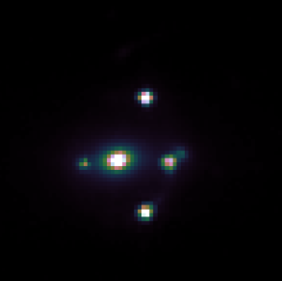 | 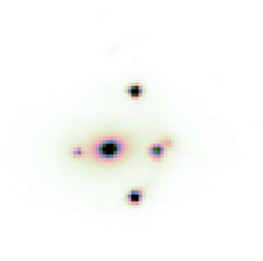  Here the blue circles are the lensed images of the quasar, and the red circle is the lensing object.  The lensed images are a similar colour, brightness, and shape.
1 | 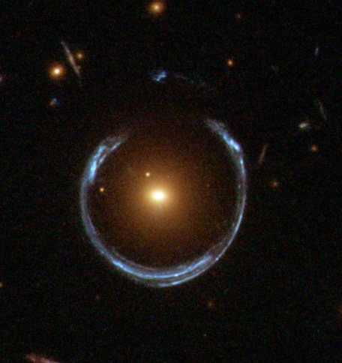 | 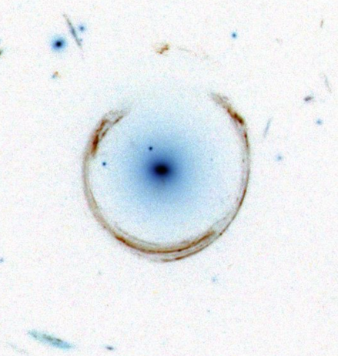
2 | 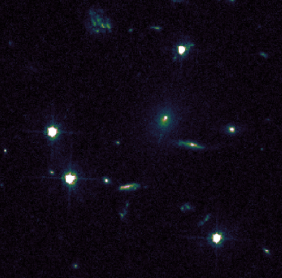 | 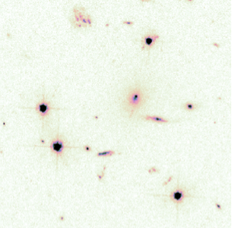
3 | 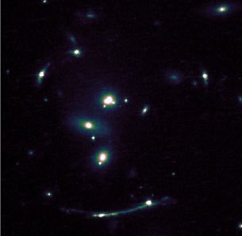 | 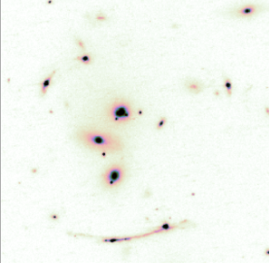  Hint: Look for arcs!

Compare these images above to the ones you see on Navigate. What makes them different? And why?

Identifying and Sorting Lensing Effects
Learning Intention: We are learning how to identify each type of lensing effects present in images
of systems discovered by the SDSS, specifically the difference between:
- Arcs,
- Einstein Rings,
- Multiple Image,
- Or a mix of everything.
Success Criteria:
- I can recognise when a telescope image features gravitational lensing effects.
- I can tell the difference between the three effects.
- I can apply the science from Voyages to explain why these images occur.
In this section you will be given a set of images that feature lensing effects. You should work together to identify the different visual effects caused by gravitational lensing and placing them under the correct headings. Some images can show numerous features of gravitational lensing.
These are the 4 categories that you’ll sort the images into:
- Multiple Imaging
- Arcs
- Both
- Einstein Rings
During this activity, discuss the following questions with your peers and then record your thoughts:
How common do you think gravitational lensing is? | Is it hard to decide if things in the images are lensed?
How many gravitational lensing systems do you think we have discovered? | How might scientists work out if images like these are due to gravitational lensing?

