Launch to the Cosmos – Edwin Hubble’s Galaxy Classification

Don’t forget to record data and observations as you work through this activity. All of the questions and reminders from the activity are listed in order below.

Understanding Hubble's Classification

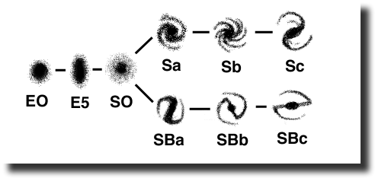
- The galaxies are sorted into categories starting with E or S on the diagram. What do you think these capital letters stand for? (Hint: What’s the difference between the shapes of the galaxies on the left versus those on the right?)

- The galaxies on the far left range from E0-E1-E2-E3-E4-E5 although only E0 and E5 are shown. What do you think the numbers indicate?

- Can you describe the shape of the S0-type galaxy in words? What makes it different from the E’s?

- What is the difference between the upper and lower forks on the diagram? What do they have in common?

- What do you suppose the "B" stands for on the lower fork? Hint: It’s another abbreviation for a feature these galaxies each have in common.

- What about the lower case letters a, b, & c? Can you describe in words what progression in shape these letters are meant to represent?

Comparing Organization Diagrams

- What similarities and differences do you observe between your classification and Hubble's?

- Did you use any characteristics to sort your images that Hubble did not use?

- Try sorting your images to match the Hubble diagram. Describe the results. If you are able, paste in an image or screen capture of your work.

- Are there any positions on the tuning fork where you have no examples?

- Do you have galaxies that don't seem to fit on the tuning fork? What do you think is the cause?

Observing Patterns and Drawing Conclusions

- What evolutionary sequence do you think might be possible when you look at the tuning fork diagram?

- Why do you think we still use the tuning fork diagram today if it doesn't describe more than galaxy shapes?

